**Host & Domain**

* The main difference between domain and hosting is that domain is the address, which allows a visitor to easily find your website online, while hosting is where the website files are stored. In order to have a functioning website, you need both – a domain and hosting space.
* The different computers connected to the Internet do not locate each other by names, but use numerical codes called IPs to communicate. 
* However, imagine that you had to remember an IP number for each website you want to visit, it would be impossible! For this reason, the domain name system was created to facilitate this task and that we can use names (easier to remember) instead of IPs to navigate the Internet.
* **Hosting is of different types the are-**
* VPS (virtual private server)
* Elastic hosting
* Cloud hosting

**VPS (virtual private server)-**

A virtual private server, also known as a VPS, acts as an isolated, virtual environment on a physical server, which is owned and operated by a cloud or web hosting provider. VPS hosting uses virtualization technology to split a single physical machine into multiple private server environments that share the resources.

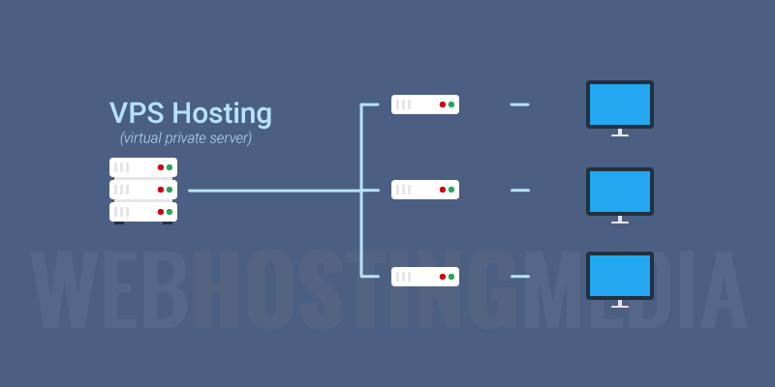

Even though you are sharing one physical server with other users, a VPS simulates a dedicated server hosting environment. Your hosting provider installs a hypervisor—a virtual layer—on top of the operating system (OS) of the physical server that divides it into virtual compartments. This layer enables each of these compartments to run its own OS and software, allowing each environment to function independently from one another.

**Elastic hosting-**

Elastic hosting is a type of hosting environment where accounts are set up on virtual “cloud” instances spread across a cluster of servers. Your web server, database server, storage server, FTP, emails, and such are all delated to separated servers (aka “horizontal scaling”).

Hosting across a server cluster adds tremendous complexity and traditionally reserved for only the most demanding enterprise needs and with highly-specialized admins and dev staff to maintain it. For organizations of that size, clustering is the only way to handle a website and traffic of that magnitude.

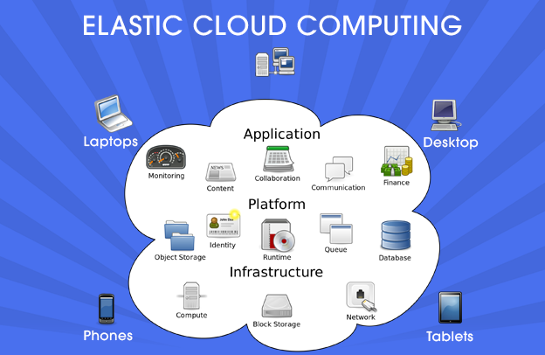

**Cloud hosting-**

“Cloud computing” is a phrase many of us hear but may not understand. This is because it encompasses several different systems and services, making it feel ambiguous or confusing.

In this article, we share a simple definition of cloud computing, examples of computing, and discuss why companies use cloud computing.

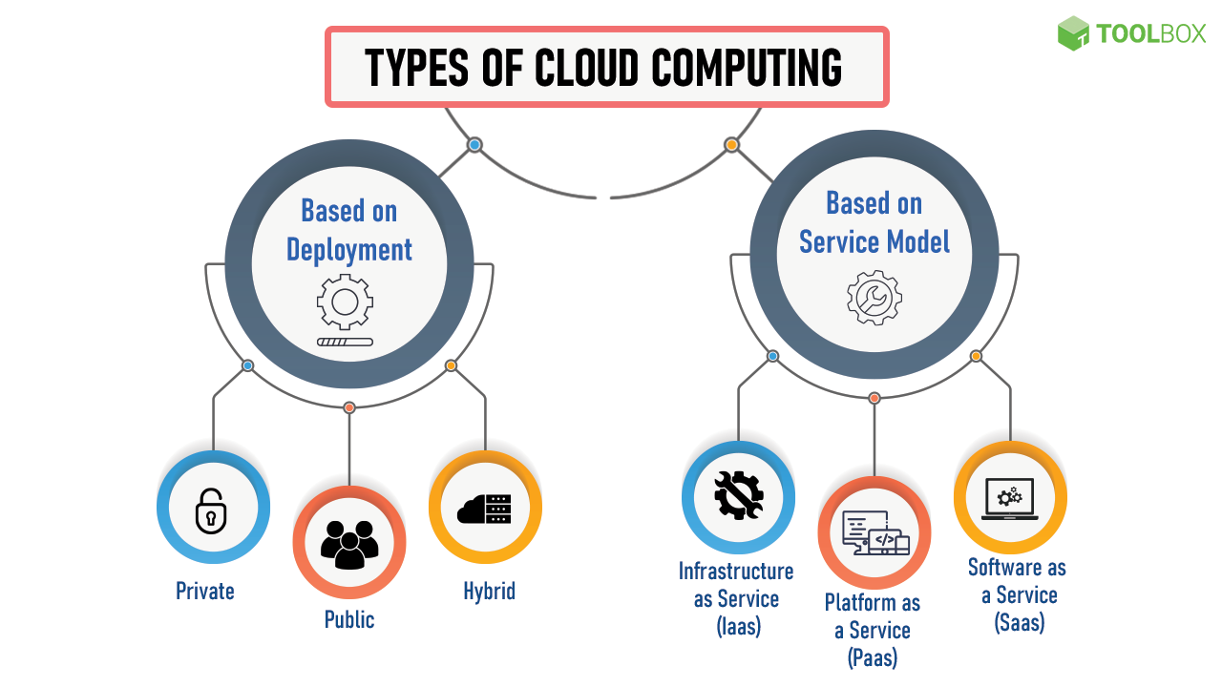

The “cloud” is a term that simply means “the internet.” Computing involves the infrastructures and systems that allow a computer to run and build, deploy, or interact with information. In cloud computing, this means that instead of hosting infrastructure, systems, or applications on your hard drive or an on-site server, you’re hosting it on virtual/online servers that connect to your computer through secure networks.